**Sep. 8 - Week 1 – The Reason For Apologetics & The Biblical Case For Apologetics**

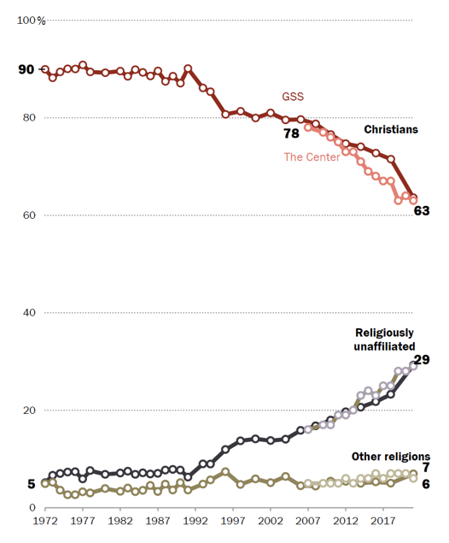**The Reason We Need Apologetics:**

* **Christian apologetics is vital for strengthening believers.**
* **Christian apologetics is vital in shaping culture and evangelizing unbelievers (Acts 17).**

**A Biblical Case For Apologetics:**

* **Jesus practiced apologetics**
  + Matthew 22:15-33
  + Matthew 11:2-6
  + Mark 2:8-12
  + Luke 24:36-40
* **The Apostles practiced apologetics**
  + Luke 1:1-4
  + 2 Cor 10:3-5
  + Col 2:8-9
  + Col 4:6
  + John 20:30-31
* *Apologia* = defense or vindication (1 Peter 3:15)
  + The rational defense of the Christian Worldview as objectively true, rationally compelling, and existentially or subjectively engaging.
  + The branch of Christian theology that:
* **Old Testament** (Isaiah 40-45, 1 Kings 18:20-40, Isaiah 1:18, Deuteronomy 13:1-5, Deuteronomy 18:20)
  + The prophets never said “God said it so you should just believe it.”
  + Genesis 1 as an apologetic against competing world-views.
  + The prophets often pointed to an orderly universe.
  + The prophets always gave a rational defense by appealing to fulfilled prophecy and miracles.

For Next Week: Read the *Introduction* (pages 1-16) of *Why God Makes Sense in a World That Doesn’t.*