Oct. 20 - Week 7 – Chapter 2b, pages 71-87

Review of Last Week: Science Uprising Video

The Meaning of the World: Math

Why do mental things exist?

Why do mathematical truths exist independently from human minds?

Doing math is like being an archaeologist who discovers what is already there.

Example: The Parabola

Why does something we discover in the abstract have a physical application to nature a thousand years later?

Three Part Cosmic Harmony:
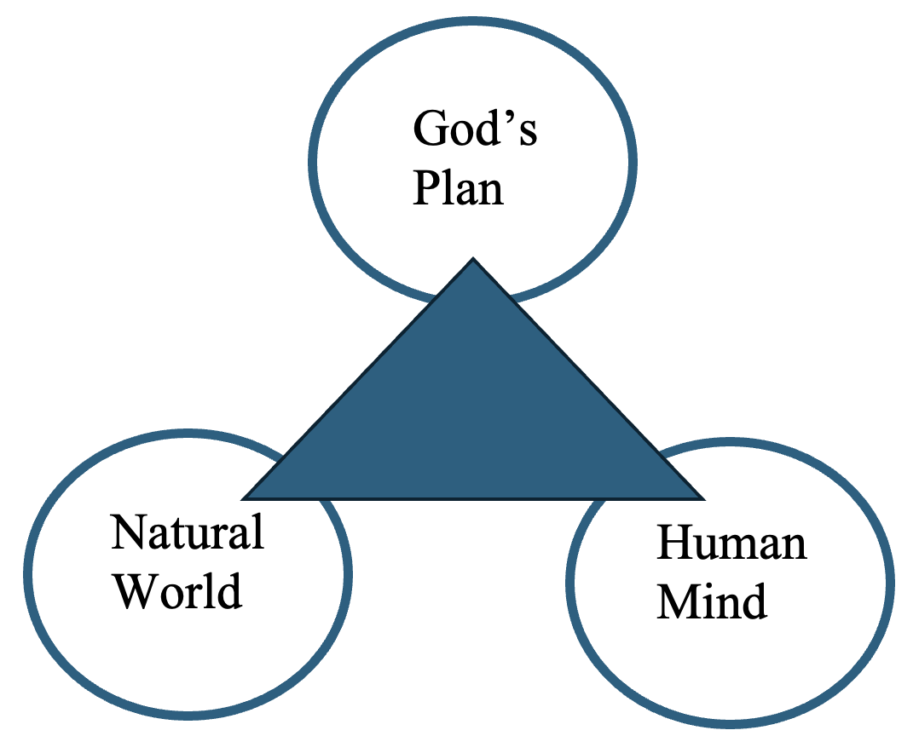

“In the pure mathematics we contemplate absolute truths, which existed in the Divine Mind before Creation.” Harvard President (1846-1848) Edward Everett in Equations from God: Pure Mathematical and Victorian Faith

“The Trinity demonstrates that numbers and relationships between numbers have always existed. The infinite nature of God demonstrates that all numbers are fixed in the knowledge of God.” Augustine - On The Trinity

- God has a numerical nature, providing a foundation for distinguishable and countable particles.
- God is omnipresent, providing a foundation for geometry.
- The three persons of the Trinity are in relationship, providing a foundation for algebra.
- God is infinite and immense, providing a foundation for calculus.

The Unreasonable Effectiveness of Mathematics. . .

“Man as scientist can be spoken of as the priest of creation whose office it is to interpret the books of nature written by the finger of God, to unravel the universe in its marvelous patterns and symmetries, and to bring it all into orderly articulation in such a way that it fulfills its proper end as the vast theatre of glory in which the Creator is worshipped and hymned and praised by his creatures.”
Thomas Torrance, The Ground and Grammar of Theology

Next Week: 87-112

