Dec. 8 - Week 12 – The Reliability of the Gospels: Chapter 4b, pages 175-182

- The Original Documents Were Written Early.

- All New Testament Books Were Written Prior to AD 70.

  - Easily within the lifetime of the eyewitnesses

- The Resurrection Doctrine is an Early Teaching

1 Corinthians 15:3-5

- Our New Testament Matches the Originals.

- More Copies & Early Copies = More Confidence

- 99.8% of variants make no difference at all

- No variants affect any doctrine

- Chain of Custody
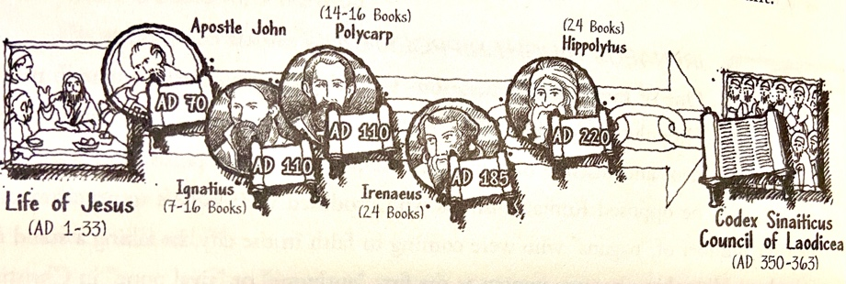

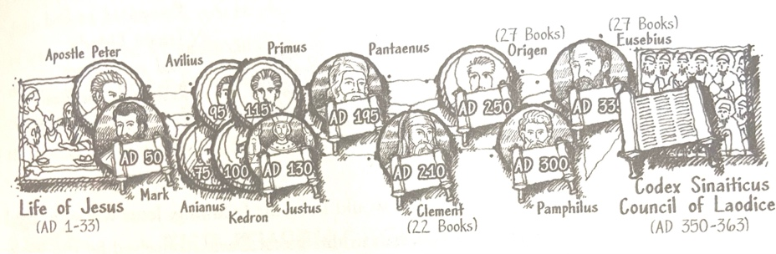

Next Week: pages 182-207

Remaining Schedule

Dec. 15 – Week 13 - Christological Argument: Chapter 4c, pages 182 – 207
The Hope of the World: Evidence for the Resurrection

Dec. 22 – Week 14 – Conclusion: Moving Forward with Possibilities

