4/27/2025

**Class #3- Buddhism**

Up Front, Most important difference:

**Buddhists believe humans can be perfected by intense self-effort & Christians do not**

see Romans 5:12, Ecclesiates 7:20, 1John 1:8, 1 Corinthians 2:14, Romans 3:23-24

**Buddhism Overview**

* 4th largest religion in the world (350m adherents)
* Based on teachings of **Siddhartha Gautama** (560-480 BC)- Nepal, raised as Hindu
* Buddhism attempted to democratize, reform Hinduism
* Some call it “scientific” or “atheistic” religion
* Not an exclusive religion: can also be a Taoist, Confucianist at same time
* Teachings include much worldly wisdom

**Life of Siddhartha**

* **BIRTH**: Born into royalty, Queen Maya (Mom) dream w/elephant, **Prophecy** from wise man
* Life as a PRINCE: **Father cloistered him**, married Yashoddara
* 29 Years- leaves palace, first time sees: **Old Age, Sickness, Death, & Monk (4 Sights)**
* Sid. Leaves wife & newborn to search for a solution for worldwide suffering (**Great Renunciation**)
* Lives 7 yrs as an ascetic
* Sits under **Bodhi Tree**, victorious over temptation from **Mara** & becomes Enlightened

**Enlightened One or Awakened One= Buddha**

* Spends rest of his life teaching the precepts of Buddhism

**Basic Buddhist Beliefs**

1. **Four Noble Truths**

-Life is **Dukkha** (suffering)

-Suffering is caused by **tanha** (selfish desires)

-**End Suffering by ending selfish desire**

-Follow the **8-Fold Path** to reach Enlightenment

1. **The Middle Way**- Buddha found enlightenment when he lived simply, practicing neither asceticism or extravagance
2. The **Eightfold Path**- 8 ways to think, act & behave that leads to enlightenment
3. **Five Precepts of Right Behavior**
4. No murder of humans or animals
5. No stealing
6. No unchaste behavior
7. No lying
8. No intoxicants

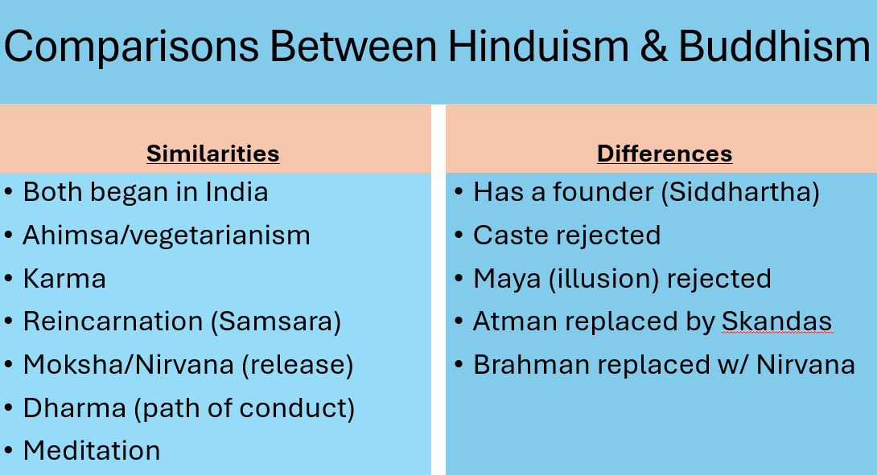

**Features of Buddhism**

* Meditation is the basic practice leading to enlightenment
* Parable of Poisoned Arrow- questions about Metaphysics are impractical
* Mindfulness leads to seeing cause & effect
* Emphasis on Compassion
* Impermanence- Life is constantly changing- Symbol=Mandala
* Afterlife/ Skandas/ Nirvana
* Buddha’s last words

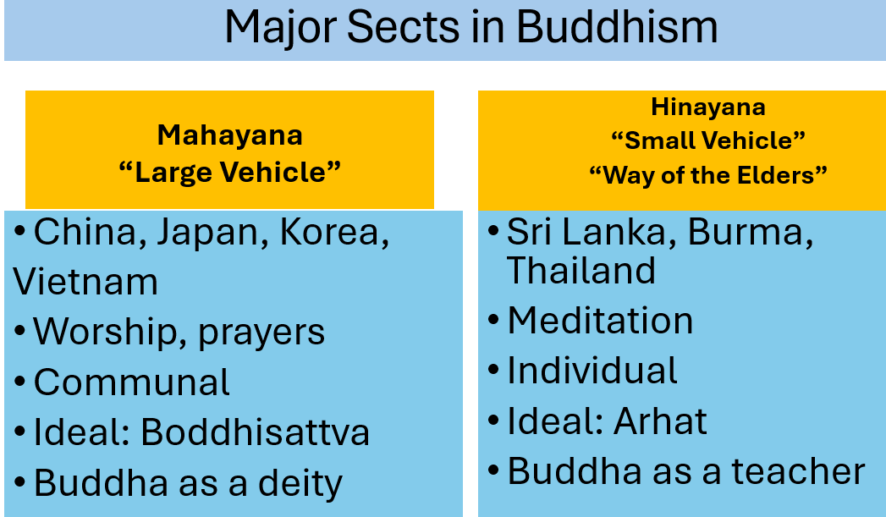

Two Other Sects: Zen Buddhism & Tibetan Buddhism

**Contrasts Between Buddha & Jesus**

