May 4, 2025

**Islam Overview**

**Basic Facts**

* 2nd largest in World (1.9 B) (20%)
* Based on teachings of Muhammed (570-632AD)
* Fastest growing in World & US
* Youngest of “historic” faiths
* Considers Abraham the founder, believes Islam is the extension of Judaism & Chr
* 49 countries Islam is the leading faith
* Only 25% of Muslems are Arabs
* Nations w/ the largest Muslem populations: Indonesia, Pakistan, Bangladesh, India

*Arabic has no vowels, so translating & spelling can be diverse: Muslim, Muslem, Moslem

**Vocabulary** Islam= submission or peace

Asalamalakum= peace be upon you (pbuh)

Muslim= one who submits

Quran= recitation, Muslim holy book

Muhammed= praiseworthy, founder of Islam

Allah= Arabic word for God

**Life of Muhammed-** Mecca was already trade center & religious center

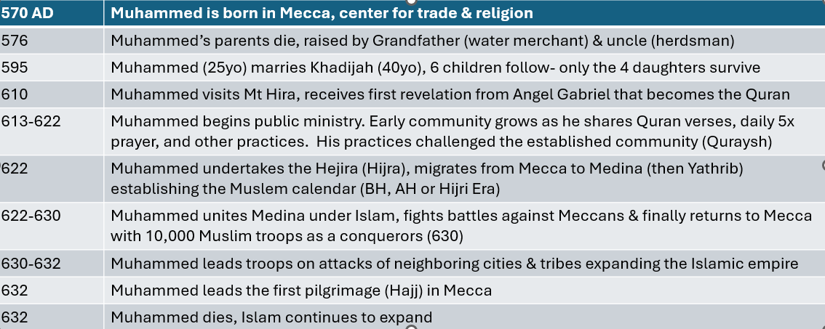

**Three Holy Books of Islam**

**Quran-** teachings of Muhammed. Most holy book.

**Sunnah**- traditions, sayings & teachings of the Prophet Muhammed- recalled by associates

**Hadith**- report or sayings from Muhammed & early leaders (many volumes)

**Sharia**= “Divine Law”…. Political direction is known as Sharia Law

**Five Pillars of Islam**

1. **Declaration of Faith-** “There is one God, Allah, & Muhammed is his prophet.”
2. **Pray Five Times Daily**
3. **Fast-** during the month of Ramadan
4. **Charity-** give $ or time to less fortunat
5. **Pilgrimmage**- once in a lifetime travel to Mecca for the Hajj ceremony

**Muslim Beliefs**

* **Monotheism**- Muslims are strict monotheists. Allah is Arabic word for God. Muhammed is a prophet, not divine. God is omnipotent & a righteous judge, more impersonal. Allah not seen as dispenser of love or grace.
* **Prophets**- Biblical prophets are accepted- Adam, Noah, Moses, David, Solomon, Jesus. Muslims believe Muhammed is the FINAL PROPHET.

“Jesus was only a messenger of Allah….. Far removed from His (God’s) transcendent majesty that He should have a son” (Surah 4:171)

* **Bible**- The Bible is considered the word of God, insofar as it is correctly translated. If there is a contradiction with Quran, Bible’s translation is corrupt.
* **Jesus**- believed to be born of a virgin, did miracles, lived a sinless life, but was not crucified. God would not allow a prophet to be crucified- it would be dishonorable

“They slew him not nor crucified, but it appeared so unto them” (Surah 4:157)

* **Abraham**- father of monotheism, the child he was to sacrifice was not Isaac but Ishmael. When Ishmael & Sarah were banished, they escaped to Mecca & sacrificed at the Meteor that became the Ka’aba.
* **Human nature** is malleable- persons are judged for their behavior & thoughts. Allah judges you after death: Heaven or Hell.
* **“People of the Book”-** Jews & Christians given special treatment, but

Christian converts are treated badly

* **Halal**= Permitted behavior, **Haram**= Forbidden behavior

Halal- Marry up to 4 wives (treat all equally)

Meat can be eaten if butchered properly

Haram (NONO)- no eating pork

no alcohol or drugs

no gambling

no adultery

no loaning money for interest

**Muslim Countries** law is based on Sharia- very harsh penalties

**Features of a Mosque-** no images, separation of sexes- women cover head, Muazzin climbs Minaret calls prayer, taps for cleaning, shoes off, Friday communal prayer, 99 Attributes of Allah

**Differences between Sunnis & Shiites**

Sunnis- vote for leader=Caliph, 80% of Muslims

Shiites- bloodline leader= Imam, 20%, commemorate Ashura- assassination Imam Husayn

-Why does Islam lend itself to extremism?

-Secular factors contributing to the rise in Islamic extremism?