**Class #5: Judaism- People of the Commandments**

**Distinctives**

* Relatively small (4 million)
* Observant Jews do not write God- G-d
* BCE for BC, CE for AD
* Crazy Calendar

**What makes someone a Jew?** Is it a religion, ethnicity, or cultural distinction? Yes

**Notable Patriarchs/Selected History**

* **Noah-** from his line “Semites” & “Hebrews”
* **Abraham**
* **Moses**
* **Aaron** sacrifices on Yom Kippur- established scapegoat (Lev 16:6-10)
* Solomon’s Temple built (597 BC)
* Babylonian Captivity 597-539 BC
* Era of the Second Temple (960BC- 70AD)

**Biblical Cycle of Disobedience**, **punishment, restoration**

* Jewish Sects at time of Jesus: Pharisees, Sadducees, Essenes, Zealots
* Roman destruction of 2nd Temple (70AD) leads to Diaspora (dispersion)

**Regional/Cultural Differences in Judaism**

* **Sephardic**-Mediterranean, Africa, Asia
* **Ashkenazic**- Northern & Western Europe, Russia

**Jewish Holy Books**

* **Torah**- First 5 books, also called Pentateuch, Mosaic Law, Books of Moses
* **Tanakh**- Hebrew Bible, Jewish Bible (aka Old Testament)- 24 Books
* **Talmud**- 63 Volumes, rabbinic interpretations compiled in 500 AD
* **Mishnah**- Oral traditions
* **Psalms** (Tehillim)- songs of David

**How Jerusalem is sacred to 3 Faiths**

* **Judaism-** Jerusalem is considered the center of Judaism.
* **Christianity-** Church of the Holy Sepulchre
* **Islam-** The Dome of the Rock is built over the Second Temple mount.

**Major Holidays in Judaism**

* **Shabbat** (Sabbath)- Day of Rest (Creation
* **Bar Mitzvah/Bat Mitvah-** “son/daughter of the commandments”- coming of age
* **Rosh Hashanah-** Jewish New Year, in the Fall, blow the Ram’s Horn
* **Yom Kippur-** “Day of Atonement”, holiest day of the year.
* **Passover-** “Pesach” commemoration of Jewish exodus from slavery to freedom.

PS- **Hannukah** is not a major Jewish holiday

**Branches of Judaism**

* Orthodox
* Reform
* Conservative
* Atheist

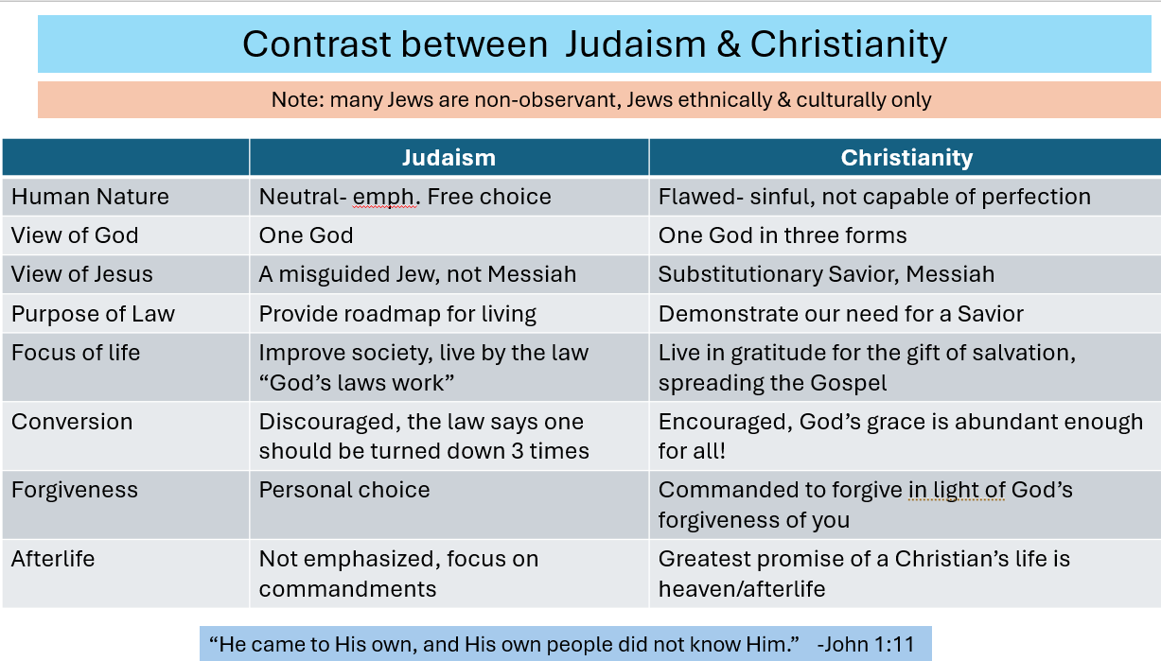

**Jewish Points of Living**

-Worship God, acknowledge His sovereignty, might, and omnipotence (Shema)

-Follow the Ten Commandments (Decalogue)

-Observe the Holy Days

-Prioritize your family

-Follow Micah 6:8… tradition of Social Justice actions

**Jewish Lifestyle Distinctives**

* Kosher
* Dairy & Meat
* Minyan- 10+ gathering for prayer or study
* Tallit & Yarmulke
* Inside a Synagogue (Temple)

**Antisemitism**-

* Reasons for antisemitism
* Examples of antisemitism