Archaeology – Week One – The Garden and the Tower
Grace Adult Sunday School

Why Should Christians Study Archaeology?

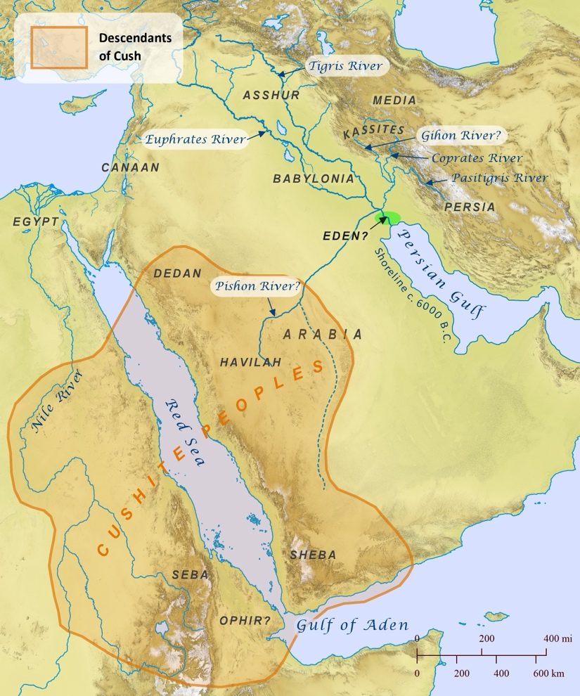
Where was the Garden of Eden?
Genesis 2:8-15

Genesis 25:18

The Pishon River (Wadi Ar Rumah) was once a massive, continuous, perennial river that flowed uninterrupted across the Arabian Peninsula

The Origin of Humanity
> Has science demonstrated that humanity could not have originated from two individuals?

Genesis 11:1-9

Migration Patterns determined by:
1. DNA similarity
2. Dating human remains
3. Tracking the use of tools (this assumes a difference between humans and animals)
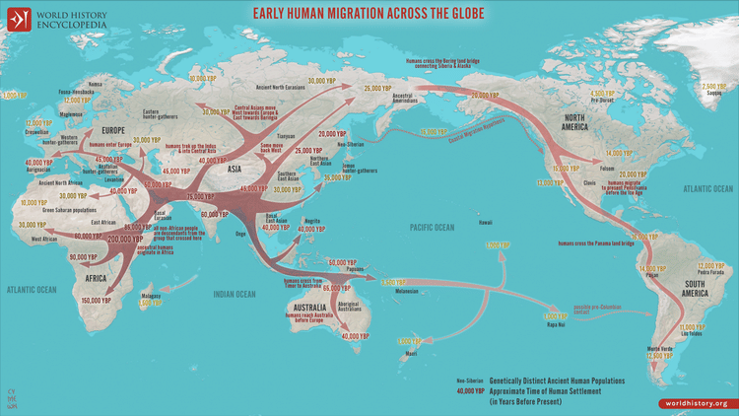

Genesis 11:1-9

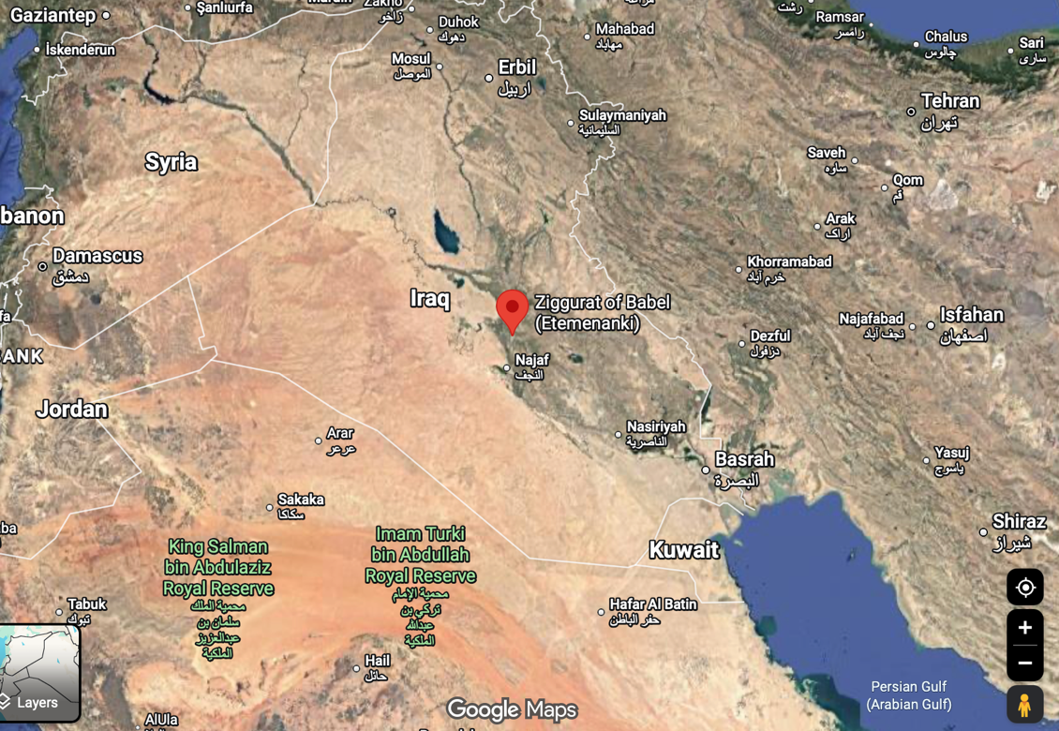
Evidence for the Tower of Babel:

Enmerkar and the Lord of Aratta – a Sumerian story dated to 2000 BC
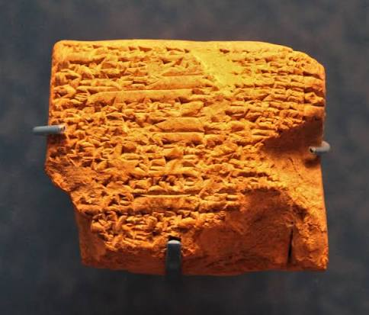
- Enmerkar attempts to construct a gigantic ziggurat
- The god Enki allows everyone to speak the same language so they can build it.

Summary:
- We have archaeological evidence that agrees with the biblical description of the location of the Garden of Eden.
- We have scientific evidence that humanity could have started as a single pair.
- We have archaeological evidence that all humanity came from a single location, at or near the location of the Tower of Babel.
- We have archaeological and historical evidence for the location of the Tower of Babel


Next Week: Abraham
Watch the following on YouTube:
Expedition Bible: The Temple Mount

Upcoming Classes
September 20 – The Patriarchs (Abraham, Issac, Jacob)
September 27 – The Patriarchs, continued
October 4 - The Exodus
October 11 - The Conquest
October 18 - Shattered Kingdoms, Babylon, Persia
October 25 - Jesus
November 1 – More Jesus

