Archaeology – Week Three – The Patriarchs, continued.
Grace Adult Sunday School
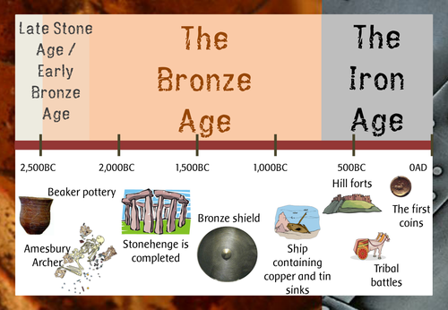
Genesis 19:15-30

Jeremiah 49:18

Isaiah 13:19-20

2000-1900 BC

Is there archaeological evidence for the destruction of Sodom & Gomorrah?

Where were Sodom & Gomorrah and the Cities of the Plain?

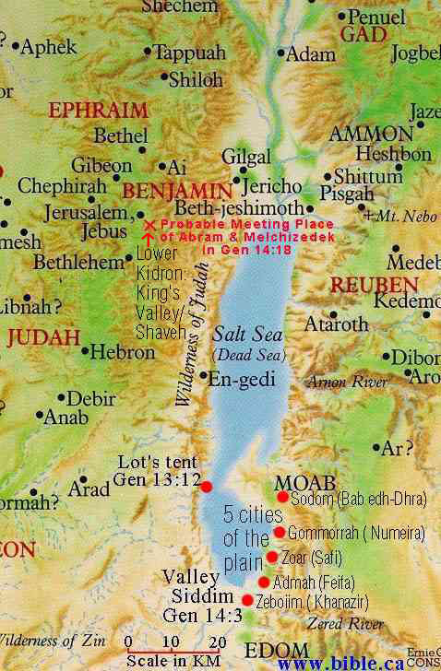
Is there evidence of the one city that was spared?

Genesis 14:1-4

Ezekiel 16:45-47

Deuteronomy 34:1-3

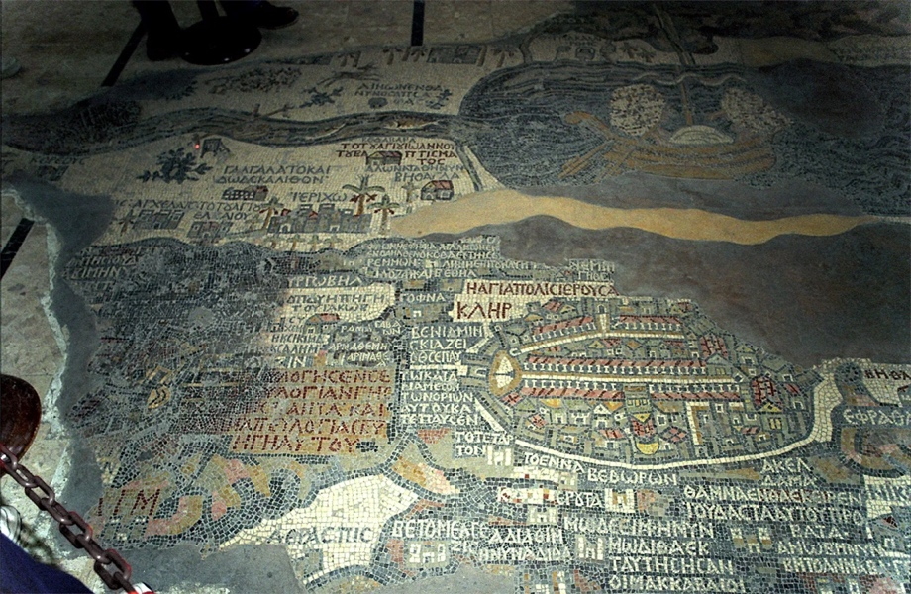
Madaba Map

Next Week:
Expedition Bible YouTube Channel:
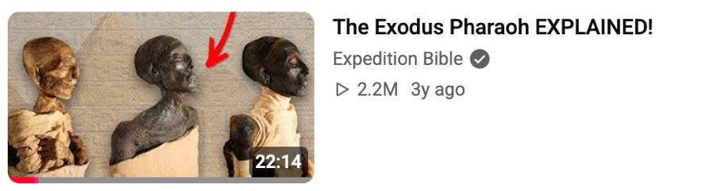
Upcoming Classes
October 4 - The Exodus
October 11 - The Conquest
October 18 - Shattered Kingdoms
October 25 - Jesus
November 1 – More Jesus

