Archaeology – Week Two – The Patriarchs
Grace Adult Sunday School

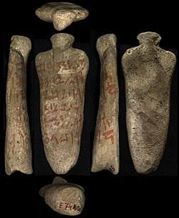
If you were to make up a story set in Roman-Britain in 400 AD, would you accurately portray all the cultural traditions and customs of the time? Would you be able to get all the names of people and places correct?

Genesis 12:1-6

Egyptian Execration Texts dated to around 1900 BC
- Confirms many of the names mentioned in Genesis.

Genesis 21:1-10

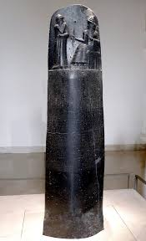
Genesis 37:28

Stele of Hammurabi dated to 1750 BC
- Inheritance goes to the son of the first wife, not the son of a female slave.
- The price of a slave around the time of Joseph was 20 shekels of silver

Genesis 15:7-10
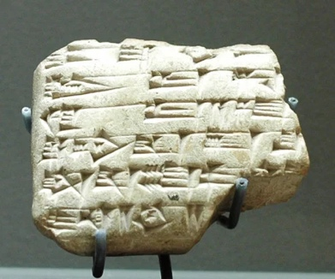
Mari Tablets dated to the 18th century BC
- Describes the covenant practice of utilizing animal slaughter when a land covenant is made to show the solemnity of the covenant.
- Includes many biblical names and places

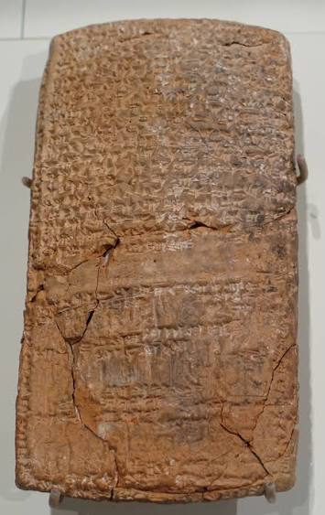

Genesis 16:1-3

Genesis 25: 29-34

Nuzi Tablets dated to the 16th century BC
- Selling a birthright for a small price
- Having children by proxy
- Deathbed blessings
- Engagement and marriage arrangements like Jacob & Rachel

Archaeology has confirmed cultural aspects of contracts, social customs, punishments, and economics in the time of Abraham. Would all these minor details be correct if Genesis had been “made up” centuries afterward?
Mamre – The Place of Promises

Genesis 13:18 Genesis 18:1-3 Genesis 18:9-10 Genesis 18:18

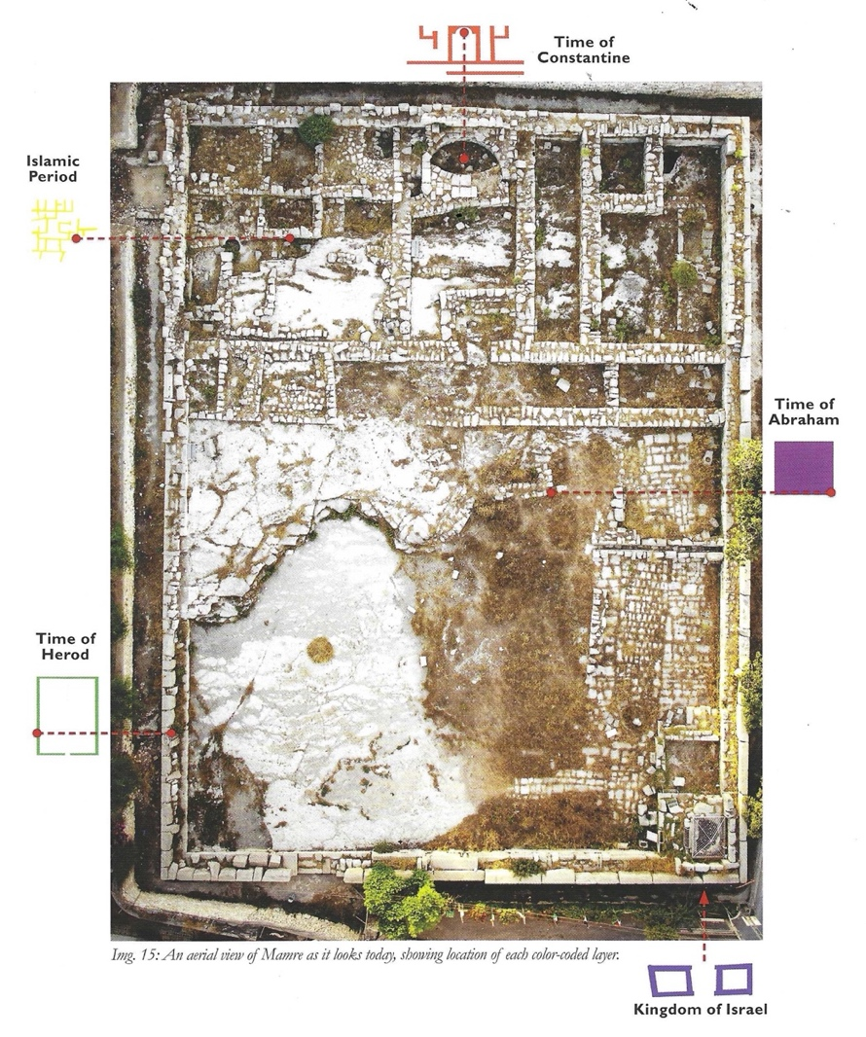
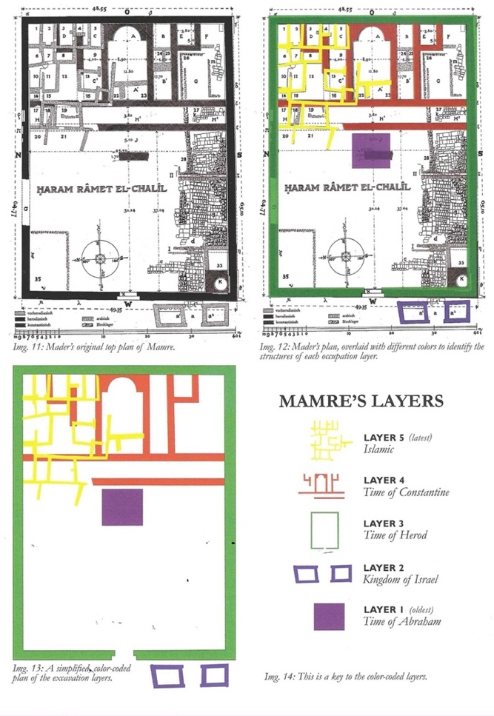

Islamic Period: ~660 – 1250 AD
Time of Constantine: 324-638 AD
Late Roman Period:2nd century AD
Time of Herod: 1st century BC
Kingdom of Israel: 1000 – 586 BC
Time of Abraham: ~2000 BC

Conclusion: Archaeology has confirmed the biblical information regarding contracts, social customs, punishments, economics, and descriptions of locations. If Genesis gets all these fine details correct, why doubt the larger story and the miracles?

Next Week: Expedition Bible YouTube Channel:

Upcoming Classes
September 27 – Patriarchs, cont.
October 4 - The Exodus
October 11 - The Conquest
October 18 - Shattered Kingdoms, Babylon, Persia
October 25 - Jesus
November 1 – More Jesus

