Archaeology – Week Five – The Conquest
Grace Adult Sunday School

18th Dynasty Egyptian Pharaohs from 1539 – 1414 BC (approximate dates)
1526 – 1513 BC: Thutmose I – ordered the killing of the Hebrew babies
1513 – 1482 BC: Hatshepsut, Thutmose II – short reign
1504 – 1450 BC: Thutmose III – 54 year reign, wanted to kill Moses
1453 – 1419 BC: Amenhotep II – Exodus Pharaoh
1419 – 1410 BC: Thutmose IV – Dream Stele Pharaoh, 2nd born
1410 – 1372 BC: Amenhotep III – Pharoh when Jericho was destroyed
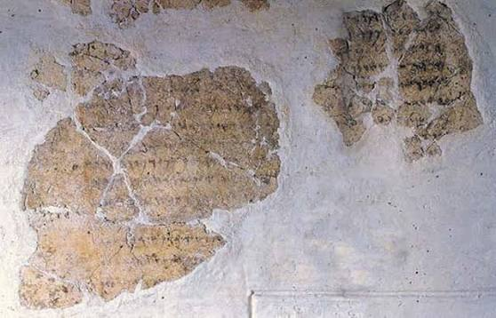
1. Deir Alla Inscription – found in Jordan and written in the 9th century BC. It tells a story about Balaam the Seer from centuries earlier.

Numbers 22:1-7

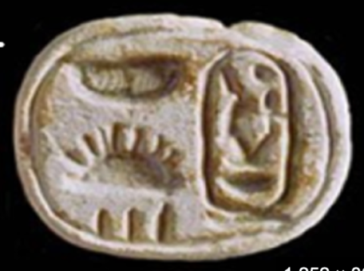
2. Scarab of Amenhotep III – found in Jericho and dated to 1410 BC. It is the last Pharoah attested by artifacts from Bronze Age Jericho.

Joshua 6:26

3. Amarna Letters - 382 cuneiform tablets from ~1400 BC.
- Found at Tel el Amarna in Egypt
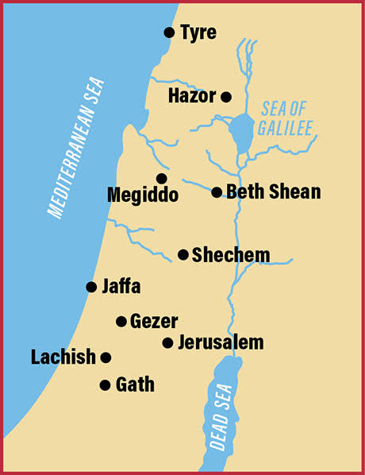
- 150 of the tablets were letters written from the Kings of the Canaanite city-states to Amenhotep III asking for help from the attacking “Habiru.”

- Shechem - What the Bible says: Joshua 8:33 Joshua 24:1

  - What the Amarna Letters say: Sent from Abdi-heba of Jerusalem, “Or shall we do like Labayu who gave the land of Shechem to the Habiru?”

- Lachish – What the Bible says: Joshua 10:22-23, 31-32

  - What the Amarna Letters say:
      - Earlier letter – Zimreddi is the ruler of Lachish
      - Later letter – “The Habiru smote Zimreddi of Lachish.”
      - An even later letter is from Sipti-Balu, the new ruler of Lachish asking for help.
      - Sipti-Balu is also eventually killed and Lachish is eventually taken.
- Gezer – What the Bible says: Judges 1:29

- What the Amarna Letters say: the ruler of Gezer asks for help, but there is no report of Gezer being taken.

- Hazor – What the Bible says: Joshua 11:10-11

- What the Amarna Letters say:
- King of Hazor asks for help in one letter
- A later letter from the King of Tyre says that Hazor was taken by the Habiru
Judges 4:1-2, 24
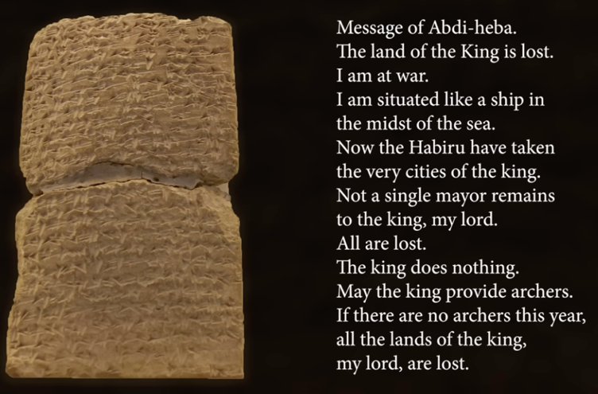
- Two burn layers at Hazor

- Jerusalem – What the Bible says: 2 Samuel 5:6

- What the Amarna Letters say:
- No report of Jerusalem being taken

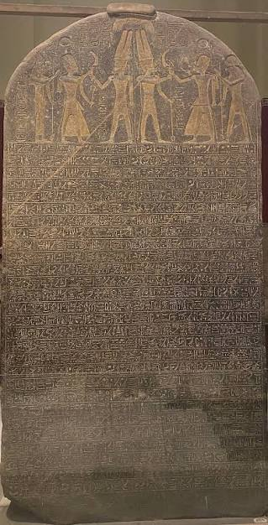
4. The Merneptah Stele – from the 19th dynasty of Egypt during the reign of Merneptah about 1219 BC.
- Evidence for Israel being the dominant people group in Canaan in the 13th century BC.

5. Jericho: Joshua 6
Archaeology agrees with the account:
- The walls fell outward.
- The walls were used as a ramp to go up into the city,
- The burn layer happened after the walls fell,
- Full pots of burned grain were left behind.
> The only problem is the date.

Conclusion:
- Hebrews were in Egypt before 1400 BC.
- Nomads of YHWH inscription around 1400 BC
- Israel is the dominant people group in Canaan in the 13th century BC.

For Next Week: Expedition Bible YouTube Channel
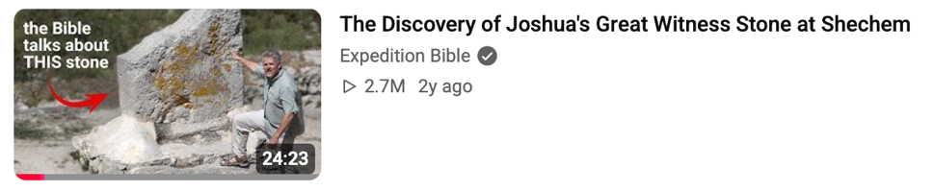

Upcoming Classes:
October 18 - Shattered Kingdoms, Babylon, Persia
October 25 - Jesus
November 1 – More Jesus

