Archaeology – Week Four – Exodus
Grace Adult Sunday School
When did the Exodus occur?
1 Kings 6:1 Judges 11:26

18th Dynasty Egyptian Pharaohs from 1539 – 1414 BC (approximate dates)
1526 – 1513 BC: Thutmose I – ordered the killing of the Hebrew babies
1513 – 1482 BC: Hatshepsut, Thutmose II – short reign
1504 – 1450 BC: Thutmose III – 54 year reign, wanted to kill Moses
1453 – 1419 BC: Amenhotep II – Exodus Pharaoh
1419 – 1410 BC: Thutmose IV – Dream Stele Pharaoh, 2nd born
1410 – 1372 BC: Amenhotep III – Pharaoh when Jericho was destroyed

Is there evidence for Hebrews in Egypt prior to 1400 BC?

1. Ben Hasan Painting – found in the tomb of Khnumhotep II (from the 12th Dynasty of Egypt ~ 1870 BC)
> Supports a Hebrew migration to Egypt
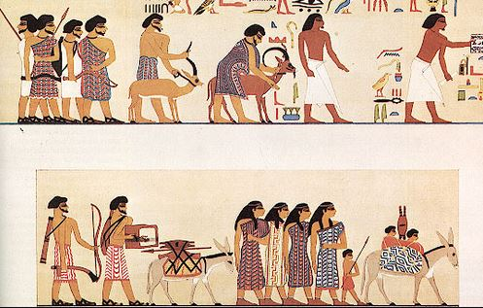
Genesis 46:1-7

2. Papyrus Brooklyn – evidence for Hebrew Servants in Egypt in the 17th century BC.

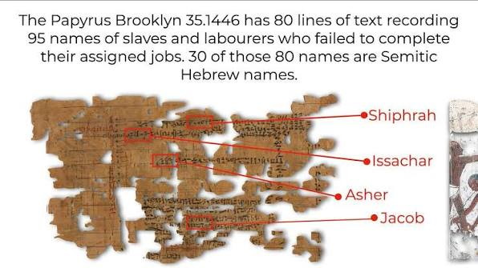

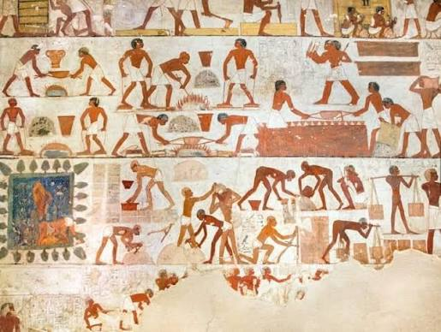
3. Tomb of Rekmire – evidence of brickmaking slaves in
Egypt in 1450 BC (from the tomb of an official of Thutmose III)

Exodus 1:8-14

4. Louvre Leather Roll – brick making quotas for slaves in Egypt (from 1274 BC)
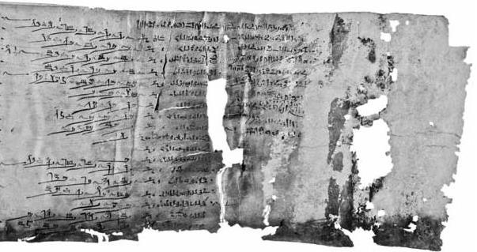
Exodus 5:10-14

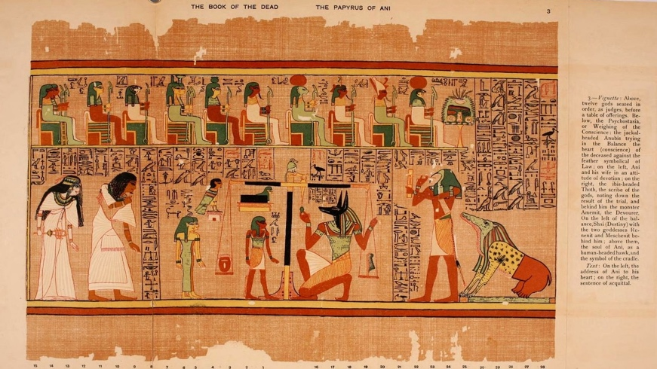
5. The weighing of the heart ceremony.

Exodus 8:32

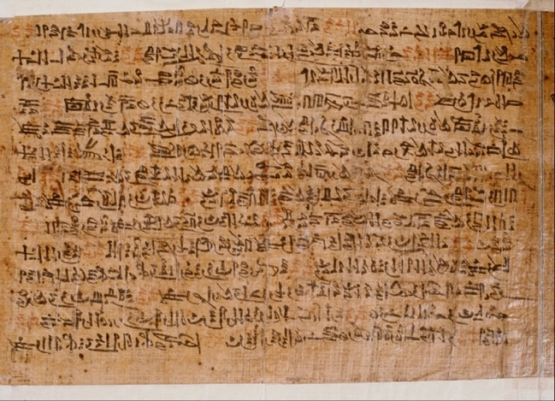
6. Admonitions of an Egyptian Sage (The Poetic Plagues)
Written before 1300 BC in Egypt describing the same general events as Exodus 7:14-12:36

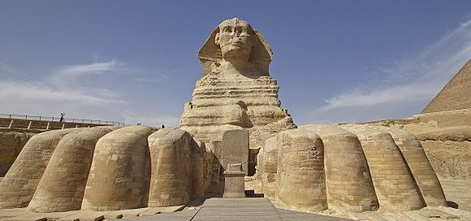
7. The Sphinx Dream Stele from 1424 BC – supports the death of Pharaoh’s first born son.

Exodus 12:29-30

8. Amenhotep II’s Tomb – The mummy of Webensenu, the firstborn son of Amenhotep II

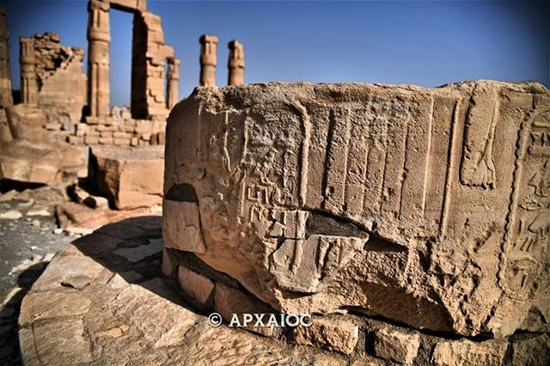

9. “Nomads of YHWH” Inscription from 1400 BC – evidence for Israel wandering in the desert.

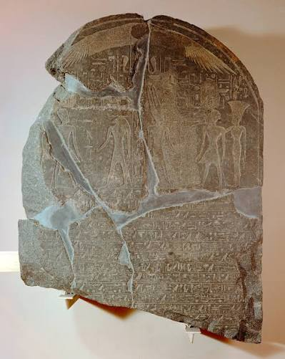

10. Elephantine Stele of Amenhotep II – the Pharaoh of the Exodus needed more slaves. In addition, this was the last campaign for Amenhotep II and war campaigns were very rare for a long time after.

12. Mummy of Amenhotep II – boils on his skin??
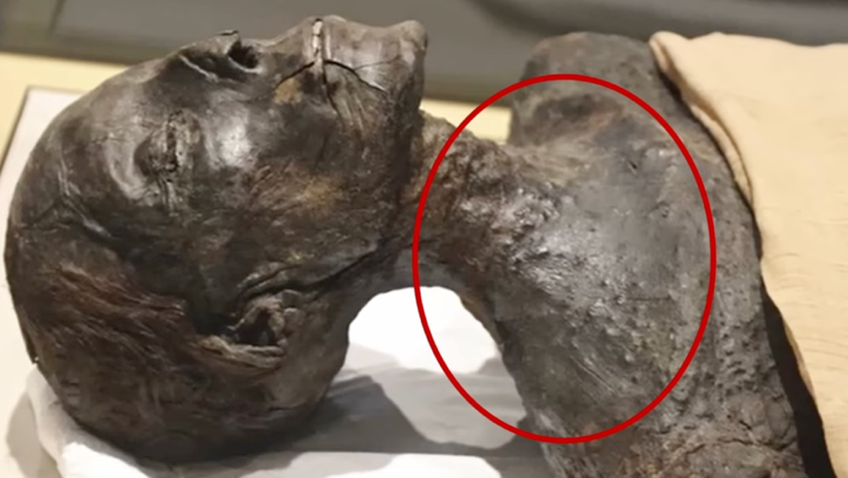

More on the Exodus: Cross Examined YouTube Channel


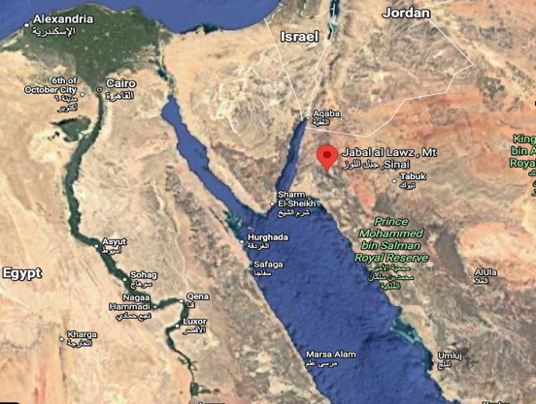

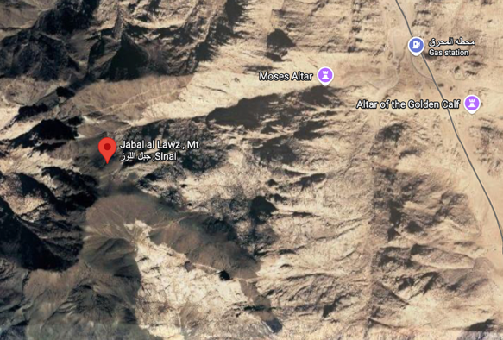

Upcoming Classes
October 11 – The Conquest
October 18 - Shattered Kingdoms, Babylon, Persia
October 25 - Jesus
November 1 – More Jesus

