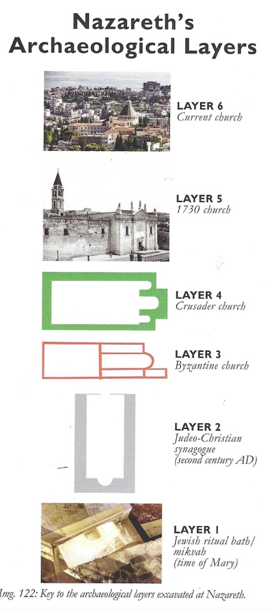
Archaeology – Week Seven – Jesus
Grace Adult Sunday School

Luke 1:26-35

First Century House in Nazareth
- Jewish ritual bath (mikvah) from the time of Mary
- Layers of archaeology mark the spot of this first century house.
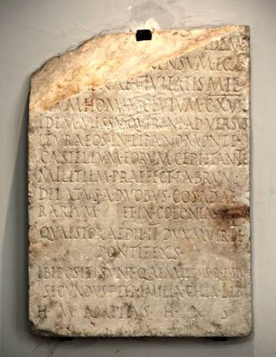

Luke 2:1-3

The Quirinius Census
- Ceasar Augustus's own autobiographical inscription, the Res Gestae Divi Augusti, confirms that the Emperor recorded imperial censuses of Roman citizens in 28 BC, 8 BC, and 14 AD.
- Lapis Venetus Inscription

Luke 2:4-7
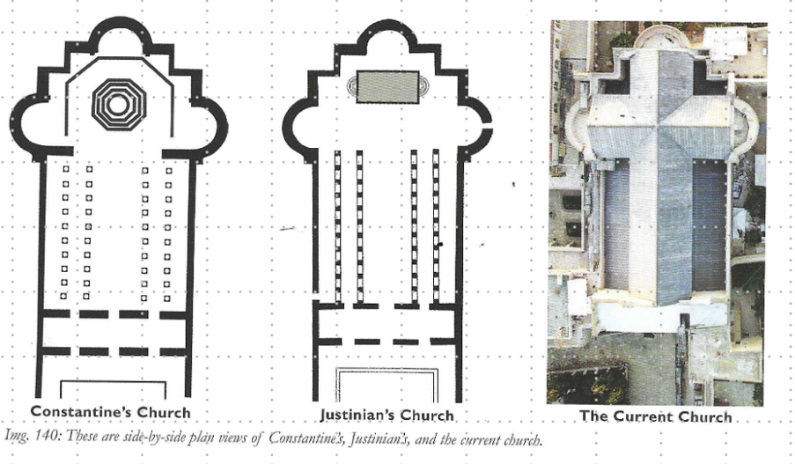
The Bethlehem Cave
- Justin Martyr wrote in 150 AD that Jesus was born in a cave in Bethlehem.
- Eusebius wrote in 313 AD that everyone knows where the cave is and people go to see it.
- Hadrian had marked the cave with a temple to Adonis.
- Constantine’s Church in 327 AD.
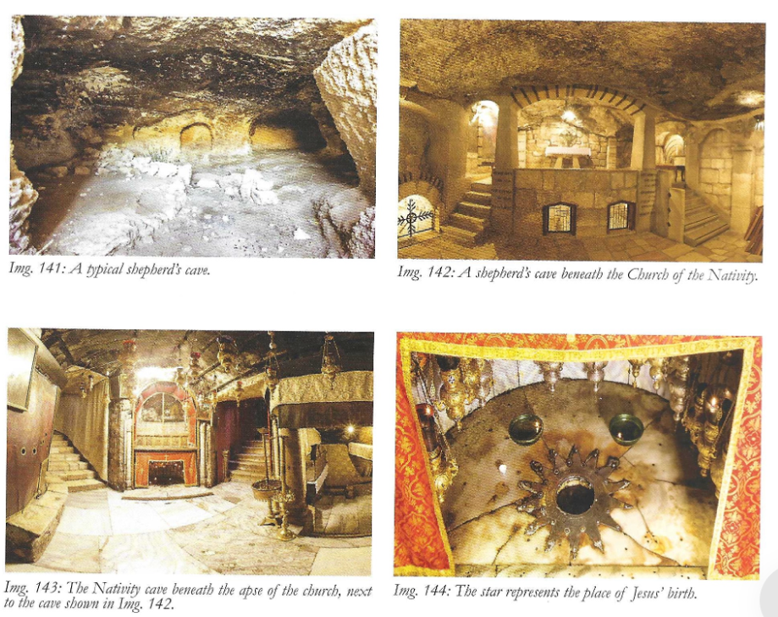
- Justinian’s Church in the sixth century AD.

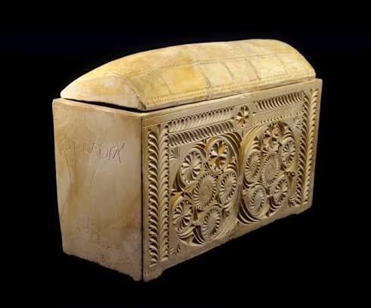
Matthew 26:57

Caiaphas Ossuary – recovered from a 1st century AD tomb outside of ancient Jerusalem. Aramaic inscription “Yehosef Qayafa” (Joseph, son of Caiaphas). Inside were the skeletal remains of a sixty year old man.

Matthew 27:1-2
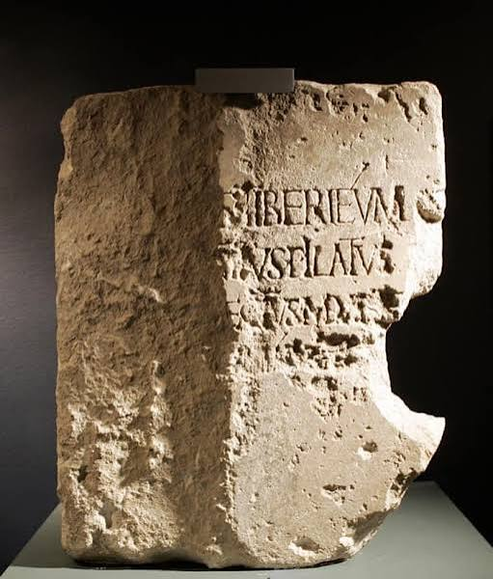
The Pilate Stone – a monument stone in Caesarea dated to 26-36 AD. “Tiberium, Pontius Pilatus, Prefect of Judea. . . dedicated.”
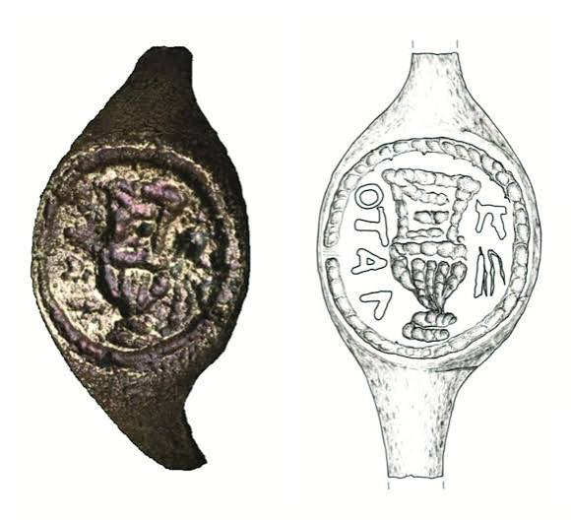

The Pilate Rings – discovered at the palace fortress site of Herodium near Bethlehem and dated to the 1st century AD. “Pilato”

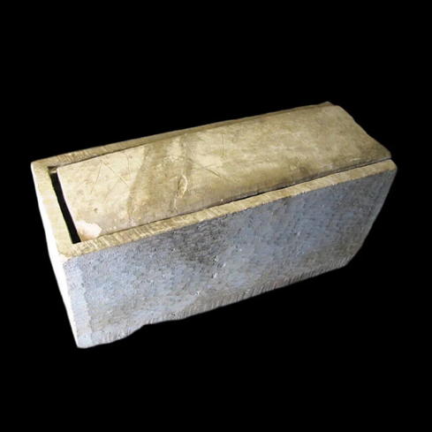

Mark 15:21

Alexander Ossuary – discovered in a tomb in the Kidron Valley. The inscription reads “Alexander, son of Simon” with the possible designation “Cyrenean.”

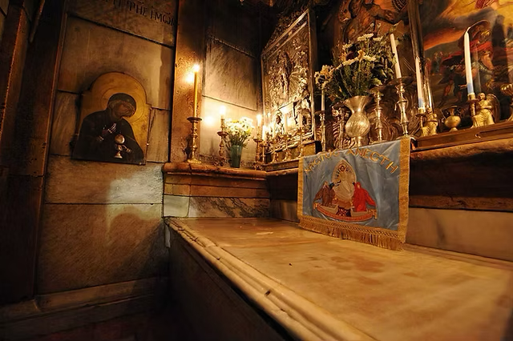

Matthew 28:1-7

The Tomb of Jesus:
- Burial bench in the Holy Sepulchre
- Stone bench within a single chamber Roman period tomb which had been sealed with a large circular stone
- Stack of archaeology marks the location

Watch these videos from the Expedition Bible YouTube Channel:
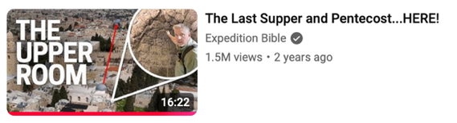
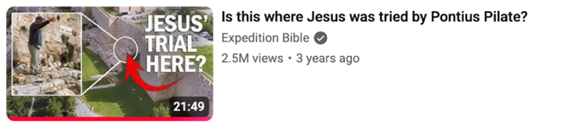
The Last Class: November 1 – More Jesus

