Archaeology – Week Six – Shattered Kingdoms & Assyrian Conquest
Grace Adult Sunday School

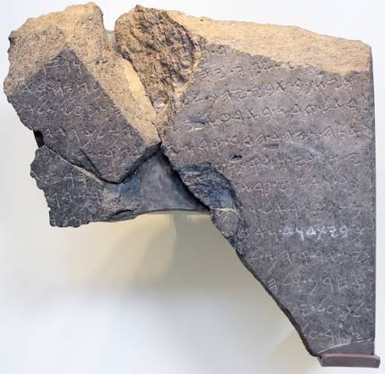
1. Tel Dan Stele – discovered at ancient Dan in 1993. A 9th century BC Aramean victory stele which narrates military victories. One of the lines says the “house of David” within the context of the kings of Israel and Judah.

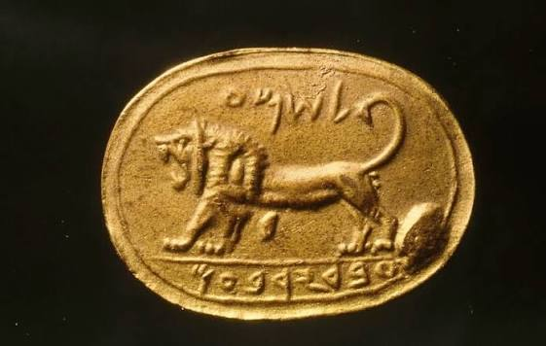
2. Seal of Jeroboam – found at Megiddo and dated to the 10th century BC. The seal reads, “belonging to Shema, servant of Jeroboam.”

1 Kings 12:20

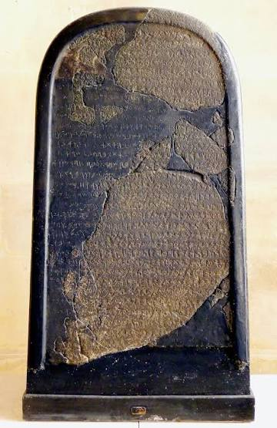

3. Mesha Stele – 9th century victory monument, discovered in Dibon, Moab
- Written by Mesha, King of Moab
- Names Omri as a king of Israel and Ahab his son
- Names Chemosh as the chief God of Moab during the reign of Jehoram.
- Names Yahweh as the God of Israel
- Contains an early reference to the “house of David.”

1 Kings 16:15-16, 29-30
Numbers 21:29
2 Kings 3:4-6

4. Bulla (an official seal) of Isaiah – Found in the same context as a bulla of King Hezekiah, dated to the 7th/8th century BC and made from the stamped impression of a signet ring. “belonging to Isaiah, prophet”
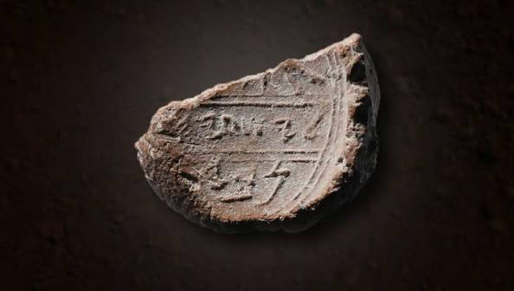

The Assyrian Conquest of Judah -

Isaiah 36:1-2
2 Chronicles 32:9
2 Kings 18:13-17
2 Kings 19:20, 35-36
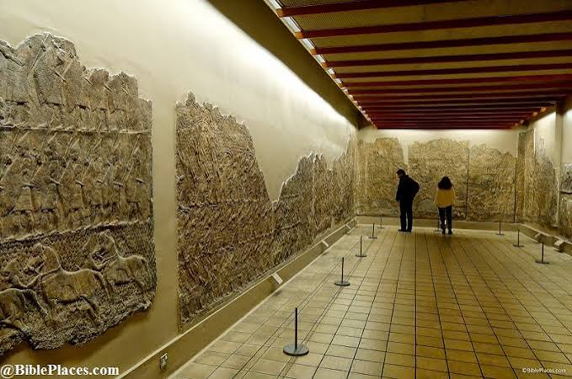
Zephaniah 2:12-14

Lachish Reliefs at Ninevah from 700 to 681 BC

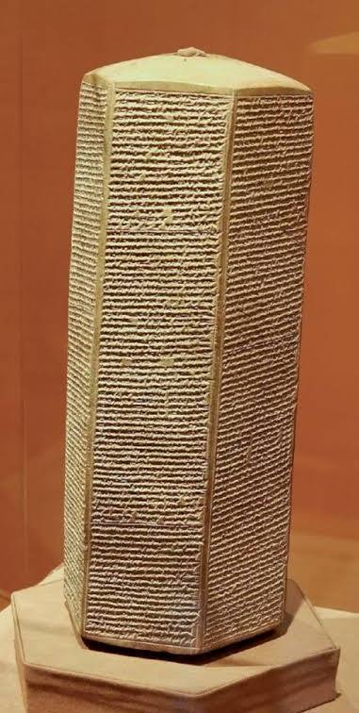
Sennacherib Prisms – evidence for the story of Hezekiah and Jerusalem .
“As for Hezekiah, that Judean, who did not submit to my yolk, I surrounded and conquered 46 of his strong wall towns as well as the small towns in their area, which were without number by leveling with battering rams, and by bringing up siege engines, and by attacking and storming on foot by mines tunnels and breeches. I besieged and took them. 200,150 people great and small, male and female, horses, mules, asses, camels, cattle, and sheep without number, I brought away from them and counted as spoil. He himself I shut up in Jerusalem, his royal city, like a bird in a cage. Fear of my lordly splendor overwhelmed that Hezekiah. The warriors and select troops he had brought in to strengthen his royal city. Jerusalem, did not fight. Hezekiah there felt the fear of the power of my arms, and he sent out to me the chiefs and the elders of Jerusalem with 30 talents of gold and 800 talents of silver and all kinds of valuable treasures”


Watch this video from the Expedition Bible YouTube Channel:

Upcoming Classes:
October 25 - Jesus
November 1 – More Jesus

