Archaeology – Week Eight – More Jesus
Grace Adult Sunday School

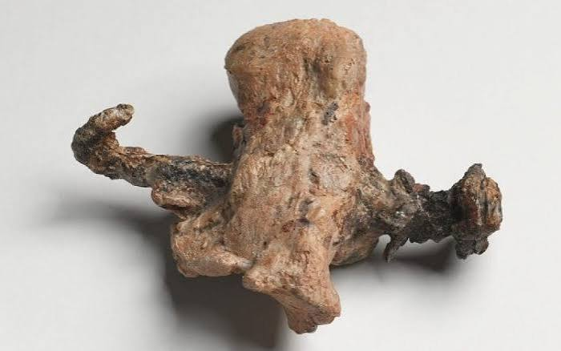
John 20:25

Crucified Man Remains
- Remains of two individuals have been found that show the use of nails in crucifixion during the 1st century AD in Judea.
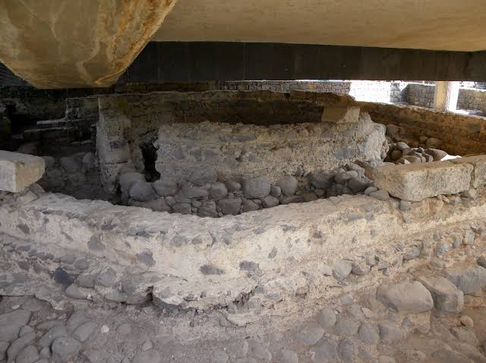

Luke 4:38-39

The House of Peter
- A modified 1st century house under a Byzantine church in Capernaum.
- Christian graffiti, including “Peter.”
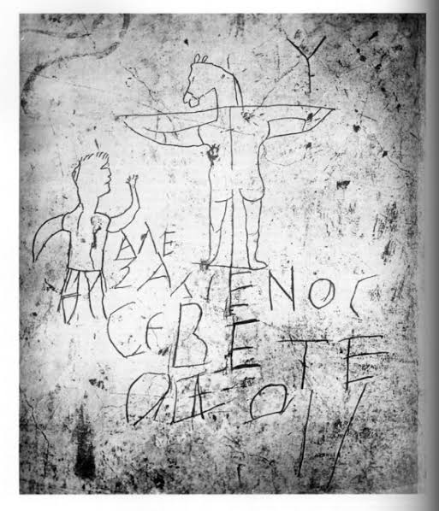

1 Corinthians 1:23

The Alexamenos Graffito
- Late 1st to early 2nd century AD inscription: “Alexamenos worships his god.”
- Discovered in Rome

Matthew 28:11-15

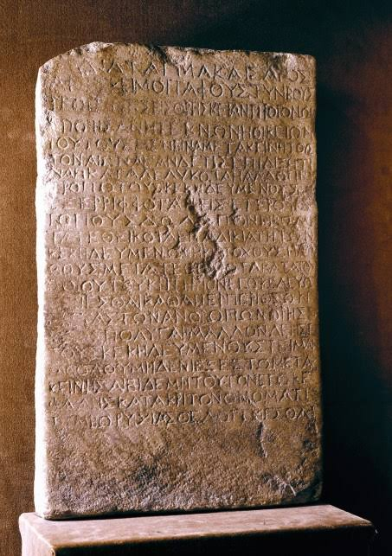
The Nazareth Inscription
- From 41 AD. An edict from Claudius Caesar which prohibits the moving or stealing of bodies from stone-sealed tombs under penalty of death.

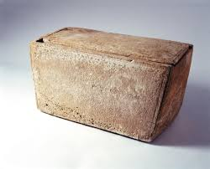
Galatians 1:19

James Ossuary
- From 62 AD. “James son of Joseph brother of Jesus”

Mark 15:22
John 19:40-42
Hebrews 13:12

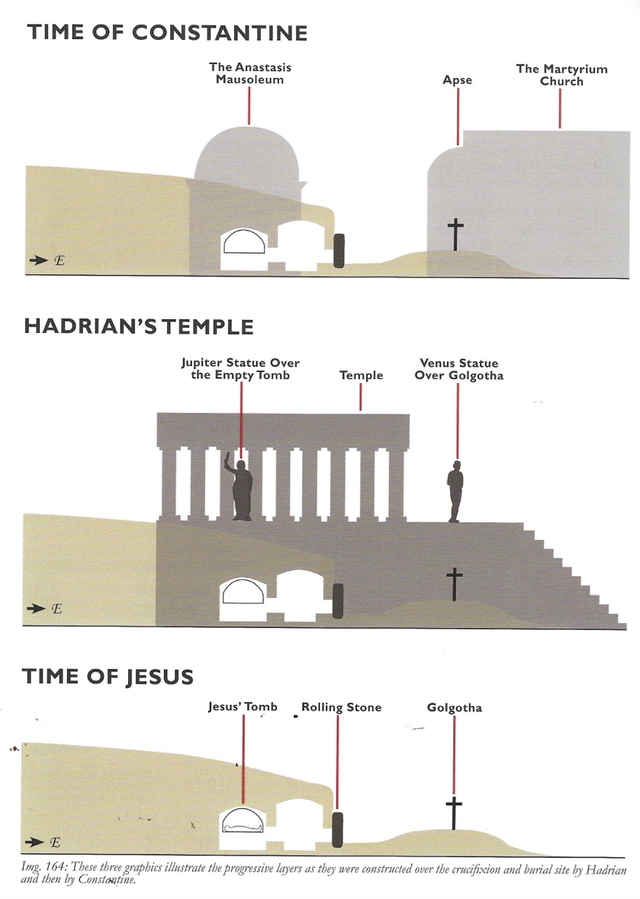
The Place of Crucifixion

